School of Electronic Engineering and Computer Science
Queen Mary University of London

MSc PROJECT DEFINITION
2023-24

This project definition must be undertaken in consultation with your supervisor. The feasibility of the project should have been assessed and the project aims should be clearly defined.
Submission of this document implies that you have discussed the specification with your supervisor.
Project Title: Use chatgpt make game NPC
Supervisor: Laurissa Tokarchuk
Student name: Jiaao Cai
Student e-mail: ec23474@qmul.ac.uk

PROJECT AIMS:
State the design, development or research challenge (problem) that the project aims to solve.

Stage1
Connect chatgpt to my game. Train the chatgpt behind different NPCCS separately to differentiate the dialogue and behavior patterns of NPCS
Finish this stage will be a successful project and OK to submit.
Starge2
Explore how much freedom chatgpt can and should gives players by adjusting chatgpt's parameters. Specific exploration direction: intelligent dialogue, quest generation, PCG, and ending orientation.

PROJECT OBJECTIVES:
List a series of objectives you need to achieve in order to fulfil the aims of your project.
Stage1
1,make game story, worldview and art resources and make them as trainning data
2,train chatgpt with game data, make them have difference
3,link that chatgpt with NPC
4,make game

Stage2
1,change flexibility of chatgpt
2,test and get player report
3,find out what kind of flexibility player like most

State how your project will be aligned with the learning outcomes of your programme of study.

METHODOLOGY:
Describe the various steps that you intend to follow in order for you to achieve your project aims.
Stage1
1,make game story, worldview and art resources and make them as trainning data
2,train chatgpt with game data and make them act different
3,link that chatgpt with NPC
4,finish game
5,write paper
Stage2
1,make 3 different flexibility of chatgpt
2,test game and get player report
3,write paper

PROJECT MILESTONES
Indicate what measurable/tangible components you will produce as part of this project. This may take the form of deliverable document(s) or developmental milestones such as a working piece of software/hardware.
Stage1
1,Can be used to train chatgpt game story, worldview and other content collection
2,Smart NPC in game connect with chatgpt
3,make different NPC act different
4,finish game
Stage2
1,give 3 different flexibility of chatgpt
2,collect player report

REQUIRED KNOWLEDGE/ SKILLS/TOOLS/RESOURCES:
Indicate as far as possible the skills that are required for you to undertake this project. Also include any software, hardware or other tools or resources that you believe you will need.

How to train chatgpt efficiently and make them act different
How to get chatgpt in unreal
How to PCG item in unreal on the basis of chatgpt
How to make chatgpt have different flexibility
Might need VR/AR Headsets

TIMEPLAN
This can be a GANTT chart submitted with this document or a list of tasks, milestones and deliverables with timings.
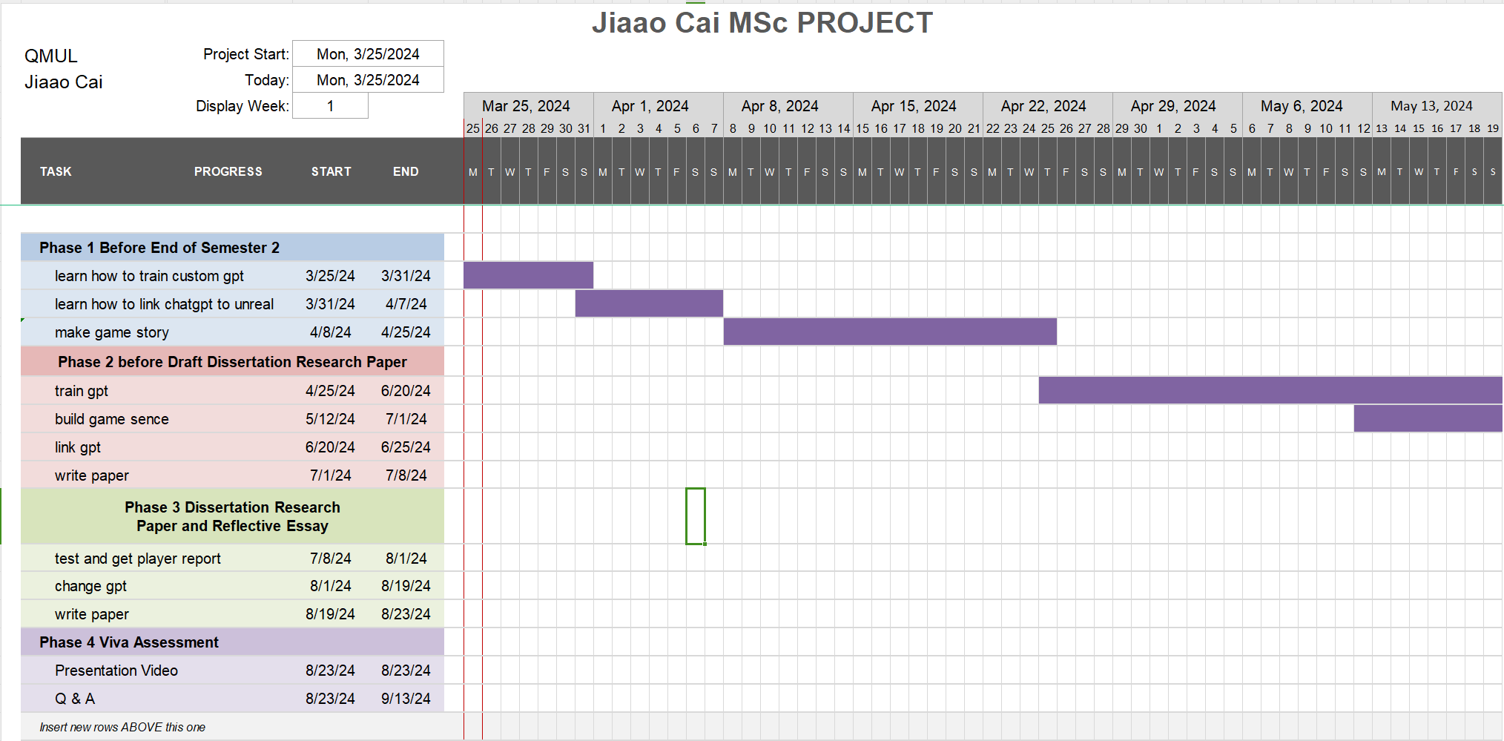
Gantt Chart Project1.xlsx

